**Exercise**

**Q1. Add 10 and 20**

To solve this problem we will take a variable sum and set it to zero. Then we will take the two numbers 10 and 20 as input. Next we will add both the numbers and save the result in the variable sum i.e., sum = 10 + 20. Finally, we will print the value stored in the variable sum.

**Algorithm (in simple English)**

* Initialize sum = 0 (PROCESS)
* Enter the numbers (I/O)
* Add them and store the result in sum (PROCESS)
* Print sum (I/O)

**Flowchart**

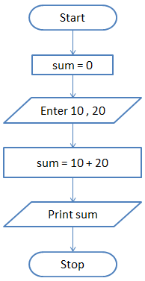

**Q2. Find the sum of 5 numbers**

In this question we are asked to find the sum of 5 numbers. So, we will take two variables - sum and count and set both of them to zero. The sum variable will store the result while the count variable will keep track of how many numbers we have read.

To solve this problem we will use the concept of loop. In loop or iterative operation, we execute some steps repeatedly as long as the given condition is TRUE. In this case we will keep reading the input till we have read 5 numbers.

So, we first initialize sum and count to zero. Then we will take the input and store it in a variable n. Next we will add the value stored in n to sum and save the answer in sum.

i.e., sum = sum + n

Then we will increment count by 1 and check if count is less than 5. If this condition is TRUE then we will take another input. If the condition is FALSE then we will print the value stored in variable sum.

**Algorithm (in simple English)**

1. Initialize sum = 0 and count = 0    (PROCESS)
2. Enter n    (I/O)
3. Find sum + n and assign it to sum and then increment count by 1 (PROCESS)
4. Is count < 5 (DECISION)
5. if YES go to step 2  
   else  
   Print sum (I/O)

**Flowchart**

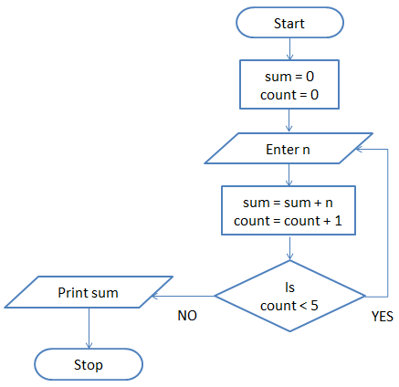

**Q3. Print Hello World 10 times**

This problem is also solved using the loop concept. We take a variable count and set it to zero. Then we print "Hello World" and increment count by 1.

i.e., count = count + 1

Next we check if count is less than 10. If this is TRUE then we again print "Hello World" and increment the variable count. On the other hand if the condition if FALSE then we will stop.

**Algorithm (in simple English)**

1. Initialize count = 0    (PROCESS)
2. Print Hello World    (I/O)
3. Increment count by 1 (PROCESS)
4. Is count < 10 (DECISION)
5. if YES go to step 2  
   else Stop

**Flowchart**

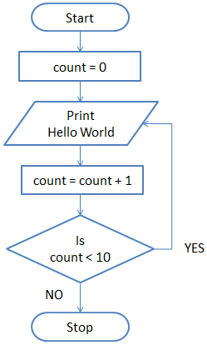

**Q4. Draw a flowchart to log in to facebook account**

This problem can be solved in many ways so, we will encourage you to think and draw a flowchart for this problem using your imagination.

To log in to facebook account we first enter the facbook URL www.facebook.com in our browser like Google, Firefox, Safari, Internet Explorer etc. This request is sent to the facebook server and it responds by sending us the home page of facebook.

Next, we enter our registered Email ID and Password and click the Login button.

Then our login credential is checked. If it is correct, we are show our profile. On the other hand, if the login credential is wrong then an error occurs and we are prompted to re-enter our Email ID and Password.

**Algorithm (in simple English)**

1. Enter www.facebook.com in your browser.  (I/O)
2. facebook Home page loads   (PROCESS)
3. Enter your Email ID and Password    (I/O)
4. Is Email ID and Password Valid (DECISION)  
   if NO then  
   Log in error  (PROCESS)  
   go to step 3  
   else  
   Display facebook Account (I/O)  
   Stop

**Flowchart**

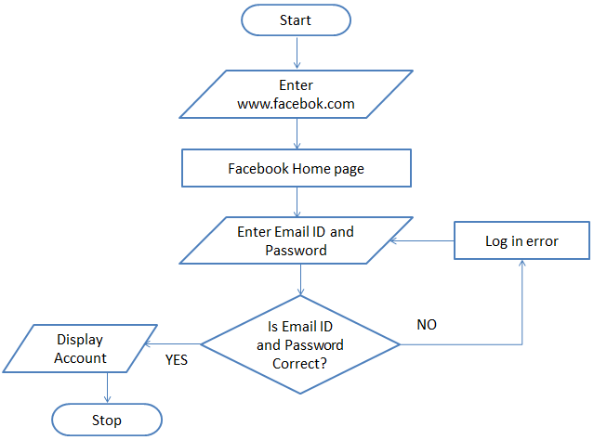

**Q5. Find the sum of the numbers in each set.**

You are given hundred numbers divided in ten sets in the following order.

Set 1: 1-10

Set 2: 11-20

Set 3: 21-30

…

Set 10: 91-100

You have to draw a flowchart that will print the sum of each set.

Solution

To solve this problem we have to apply the concept of loop which was covered in exercise-1.

Algorithm in simple English

1. Initialize count = 1 and i = 1 (PROCESS)
2. Check if i is less than or equal to 10 (DECISION)  
   if YES then perform step 3  
   else STOP
3. Set sum = 0 and j = 1 (PROCESS)
4. Check if j is less than or equal to 10 (DECISION)  
   if YES then perform step 5  
   else perform step 9
5. Add count to sum  
   sum = sum + count (PROCESS)
6. Increment count by 1  
   count = count + 1 (PROCESS)
7. Increment j by 1  
   j = j + 1 (PROCESS)
8. Go to Step 4
9. Print sum (I/O)
10. Increment i by 1  
    i = i + 1 (PROCESS)
11. Go to Step 2

**Flowchart**

